COLLECTION OF READY OCI CARD
Please visit our website: ww.cgimilan.gov.in. You can see the opening page as under:

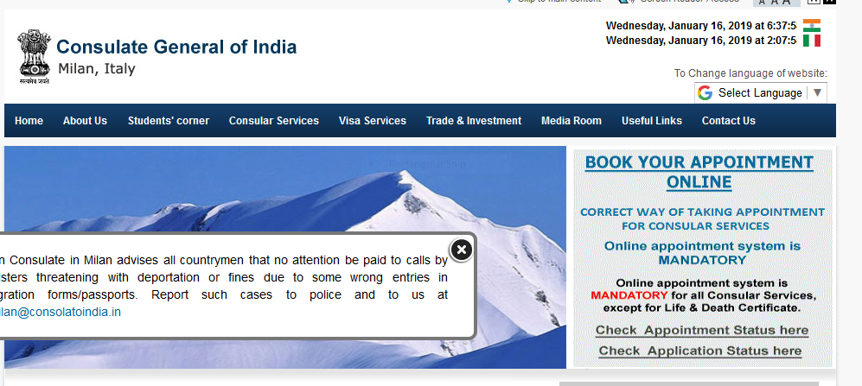
Please Click on the “BOOK YOUR APPOINTMENT ONLINE” button. It will you take you to a screen as under :

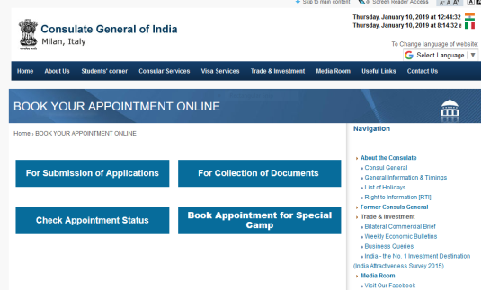
Once you click on the Button “for Collection of Documents”, it will take you to a screen as under:

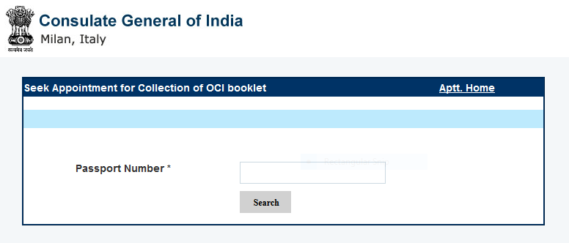
Please enter your Foreign Passport Number and Click on the “SEARCH” button. and it will take you to another screen, as under :

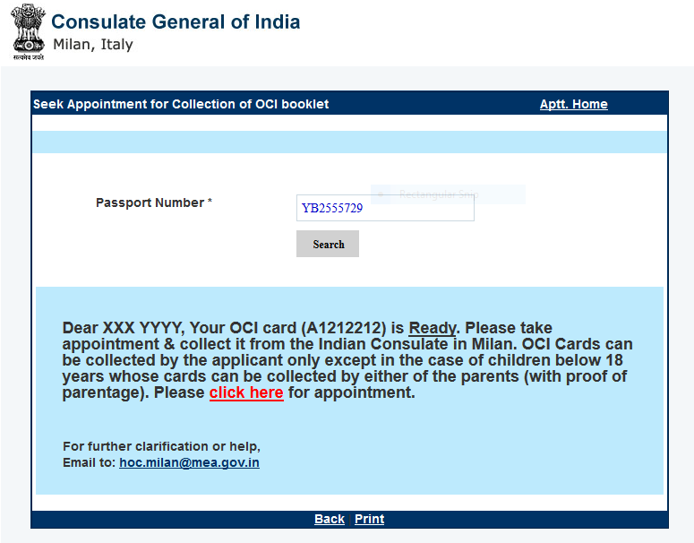

( If the OCI CARD is not ready for collection, it will state that : “Your OCI Card is not ready for collection. Please book appointment after checking status of your application. For further help please mail to: hoc.m.milan@mea.gov.in”).
Please click on the “click here” button, if your Passport is ready, and a new screen will appear as under:

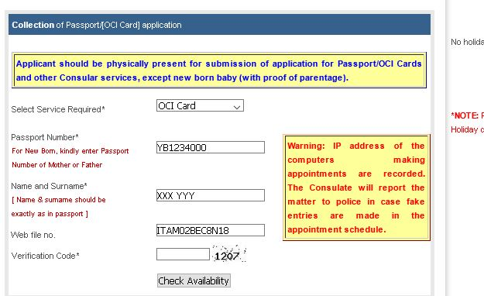
ITAM021MNB18

Please enter the Verification Code and thereafter click on “Check Availability” and the next screen will appear as under :
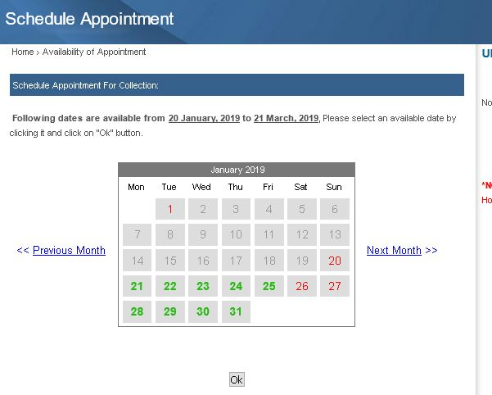

Available dates are shown in GREEN COLOUR. If no dates are available, the dates will be displayed in RED colour. If no date is available in the particular month, you can click on the button “Next Month” shown on the right side of the calendar. You can choose the date as per your convenience and click on the date. Once you click on the selected DATE, please click on the “OK” button and it will take you to the next screen as under :
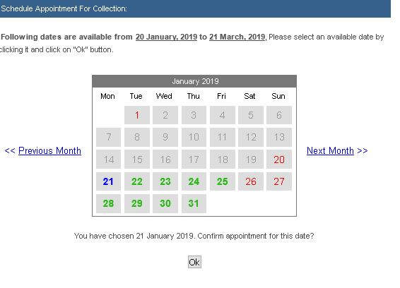

As can be seen, the date you selected turns into BLUE. Please click on “OK” button and your appointment is booked for the date you selected and the confirmation will be displayed as under :
